Soil Shields

This is a really handy idea brought to us by one of our customers to protect the root zones of newly planted trees. Many have since tried it and report good results.
Our customer lived in Cottage Grove and planted Noble Fir every year. Being a high elevation specie, it prefers a cool mountainous climate and is very intolerant of heat and dry soil. Additionally, we often couldn’t get the trees to him as early as his dry southerly location required because of rain in our more northerly farms.
He solved his problem by installing a simple paper plate, drilled in the center and sliced from edge to center hole. He would slide a plate around each tree, placed face up. Any rain that came along would funnel the moisture into the root area. The plate choked out competing weeds in the immediate vicinity which also discouraged mice from crossing the open area to chew on the stems. Best of all it shaded the root zone and kept it moist which helped the trees get established.
The wind didn’t blow away the plates and they disintegrated in about a year. His only problem: occasionally a curious Blue Jay would pull them off.
His survival rate went from 64% to 98%. At the current 1000 price, that’s at least $193 worth of trees.
It’s not hard to do and not expensive. Paper plates sell for around $35 - $50/1000. During handling, individual plates tend to bounce and the stack may separate so we find splitting the package into thirds or quarters works best. Tape around the edges to hold the smaller bundles together. Drill a hole big enough accommodate a tree stem and use a table saw to create a slice from edge to center. Finish cutting with a hand saw if the table saw didn’t reach the center properly.

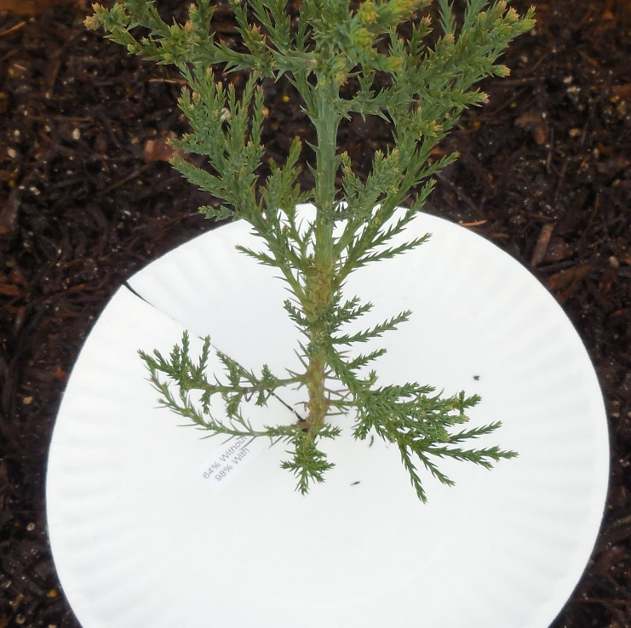
Ready to install soil shields are available here for $9/100 or $65/1000.

