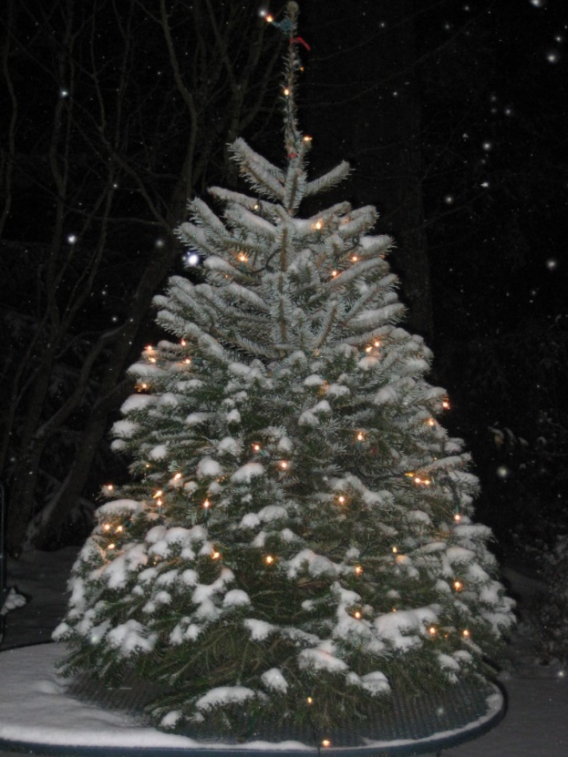
So… You Are Thinking About Growing Christmas Trees
Christmas trees are fun, can be profitable and are guaranteed to be a lot of work.
Lesson 1 out of the way. (That was the last part of the introduction.)
Lesson 2. Decide on your goals. That seems obvious but, particularly important when tax abatement is a high priority. Interested in growing for personal use only? Choose and Cut? Commercial?
Lesson 3. Consider the site/workload. We can’t grow pineapple in Oregon. Loving Noble Fir but having a low elevation wet site is never going to work. Everyone wants the tree that doesn’t get bugs or diseases, doesn’t need any work or chemicals and is in such high demand buyers will pay top dollar to flock to purchase the field on the stump and do the harvest. Don’t laugh… we actually get those calls.
Lesson 4. Resources. The Pacific NW Christmas Tree Assoc admits any interested grower. The membership fees are reasonable and they offer training meetings twice a year and a tour each summer.
http://pnwcta.org/. Sign up and attend every meeting to learn and meet people who will help.

OSU puts on “Tree School” each Spring. More for small forestry interests, there is often applicable information. https://extension.oregonstate.edu/tree-school/tree-school-clackamas
Some community colleges offer courses in farm management, forestry and so on, that might be useful.
Overall, all trees need sunny, well drained soils and will need to be trimmed to keep them from being too sparse or too wide. Weeds will need to be controlled and they all get bugs or diseases that need to be managed. Some more than others. More when the site/specie plan causes struggling growth. Consider buying larger (more expensive) trees the first couple of years to get a head start. Buyers expect baling, commercial buyers need Or Dept of Agriculture inspections and shipping permits.
Let’s talk specifics. First the end use options. Then the species.
Personal Use: if you have a forest and want to tuck in a few fun Christmas trees for friends and family you might have to pay top dollar for a handful of trees but ask when you buy the forestry trees. Some nurseries have a 100 minimum, some will sell fewer for a substantial upcharge for labor and re-packing.
Commercial Sales: Limit to one or two species that will grow on your site and meet your workload comfort. Commercial buyers purchase in larger amounts and they will want a reliable supply so plan regular annual plantings in commercial volumes. Taking care of one or two kinds is enough of a learning curve up front. Help with shearing and management service is better handled with one or two species. Plan where the trees will be staged for baling and loading a semi-truck. Plan for a turn-around space. Those areas will need to be graveled to keep trucks from getting stuck and to keep the trees clean.
Choose and Cut: Retail can be fun and dreaming is the best part anyway so do it well in advance. Growing one or two species is simpler and a frequent strategy but consider offering choices. Trees will need to be planted regularly to provide a steady flow and you will need that steady flow for retail. Nothing is worse than spending five years getting ready, three years selling the first trees and then having nothing to offer because there was a planting gap. Sad faces when you can’t meet the customer expectations means losing the market you built up.
We suggest planting a little heavy in a fast-growing specie like Douglas Fir and some slower growing trees the first year, add in some additional trees each subsequent year. The trees don’t all grow the same rate and planting a tad heavy the first year will allow for some mistakes and still get some trees ready for sale as quickly as possible.
Dream/consider the other necessary aspects of having the public come in. Where will they park? How will you/the customer get into the field and get the trees out? Allow for a gravel road with parking around the edge? One way only or wide enough for two way? Have wagons hauling people and trees? Consider where you will be in the early days when arrivals are few and you need to see the parking area. Consider where sales transactions will take place when the traffic gets busier and whether fun additions like a fire pit, animal pens, wreath sales or other extras will be of interest. Those plans don’t need to be definitive and the hardscapes don’t need to be installed right away but planning the locations for a sales area, parking lot and future amenities will make the eventual installation smoother and less costly.

Christmas Tree Species:
Noble Fir: Prefer cool moist sites at elevations over 1000’ but will grow at lower elevations if the soil is well drained. May have longer, lighter colored needles and be more prone to disease under stress. Medium Slow growing, 6-7 years to 7’/8‘ sale size. Good postharvest needle retention.
Grand Fir: Prefer Cool well drained sites. Get diseases and aphids under stress. Fragrant. 5-6 years to 7’/8‘ sale size. Medium post-harvest needle retention for late cut trees, poor needle retention for early season cut.
Douglas Fir: 5-7 years to 7’/8‘ sale size. Good postharvest needle retention.
Nordman Fir: European favorite, tolerates wet soil, hot soil, low elevations where Noble Fir does poorly. Slow growing, little to no fragrance. Needles dark green, lay flat on the stem. Has a tendency to grow wide if not carefully sheared. 7-9 years to 7’/8‘ sale size. Excellent post-harvest needle retention.
Turkish Fir: Close cousin to Nordman Fir, also tolerates wet soil, hot soil, low elevations where Noble Fir does poorly. Slow growing, little to no fragrance. Has a tendency to grow wide if not carefully sheared. Needles slightly more erect. 6-9 years to 7’/8‘ sale size. Excellent post-harvest needle retention.
Scotch Pine: Not widely grown except in very wet soils where options are limited and production ground needs to be useful. Easy, will tolerate just about all soils. Best marketed at 3’ to 5’ size for dense, even form. Usually a low-priced product. Can be useful for small rooms where price and space are a consideration. (Dorms, apartments) Sometimes used in promotions BYGO
Norway Spruce: Not widely grown for Christmas tree in the Pacific NW where firs do well but widely used in colder climates where choices are more limited. Shears nicely. Medium fast growing, usually sold as a small tree in PNW. Tolerates moist sunny soil. 5-6 years to 7’/8‘ sale size. Medium post-harvest needle retention for late cut trees, needle retention uncertain (consider it unreliable) for early season.
Colorado Spruce: Slow growing for medium to moist soil. Grown from seed they can run from quite blue to medium green. The blues may be of interest so some buyers but the needles are stiff and sharp. Needle retention acceptable for late season cut only. 7-10 years for 7’/8’ tree.
Giant Sequoia: Fast growing, best as a potted tree. Foliage is overlapping and cedar like. Pale green. Make a nice yard tree in large gardens. Tolerates moist soil. Occasionally used as a cut tree but needle retention not reliable. Will reach 7’ in 4-5 years.

